**P210/1**

**HISTORY**

**Paper 1**

**Jul/Aug 2016**

**3 Hours**

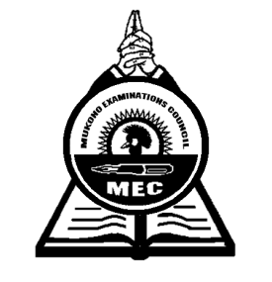

**MUKONO EXAMINATIONS COUNCIL**

**Uganda Advanced Certificate of Education**

**HISTORY**

National Movements and the New States

Paper 1

**3 Hours**

**INSTRUCTIONS TO CANDIDATES**

* *Attempt any* ***four*** *questions*
* *Any extra question(s) will not be marked.*
* *All questions carry equal marks.*
* *Begin each question on a fresh page.*
* *Relevant examples (depth), clear explanations, accuracy of information, good level of communication, presentation of many facts among others are part of impression.*

1. How far was Communist China responsible for the development of Modern African Nationalism? ***(25marks)***
2. To what extent was the Wal Wal incident of 1934 responsible for the outbreak of the Italo-Ethiopian crisis?  ***(25marks)***
3. “Economic factors were primarily responsible for the Rwanda revolution of 1959” Discuss. ***(25marks)***
4. Examine the causes and effects of the Angolan Civil war between 1975 – 2002.

***(25marks)***

1. Discuss the main features of Obote’s socialism in Uganda. ***(25marks)***
2. To what extent was the Soweto uprising of 1976 responsible for the collapse of apartheid in South Africa? ***(25marks)***
3. Examine the contribution of Dr. Kwame Nkrumah in the development of the Pan African Movement. ***(25marks)***
4. To what extent is the concept of Non Alignment relevant today? ***(25marks)***
5. Examine the role of Kiswahili in the promotion of national unity in Tanzania.

***(25marks)***

1. “King Idris was primarily responsible for his downfall in Libya.” Discuss. ***(25marks)***

***End -***